RUSMIDDELEKVIVALENTER

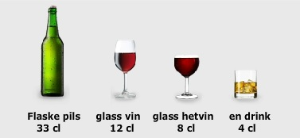

RUSMIDDEL | BRUKT MENGDE | EKVIVALENT MED

ALKOHOL
 | 1/2 flaske lettøl (33 cl)  1/2 flaske pils (33 cl)  1/2 liter pils  1/2 flaske export (33 cl)  1/1 flaske bordvin  1 glass bordvin  1/1 flaske hetvin  1 lite glass hetvin (7 cl)  1/1 flaske 40% brennevin  1 drink brennevin (4 cl)  1/1 flaske 60% brennevin | 0,5 Alkoholenhet  1,0 Alkoholenhet  1,5 Alkoholenhet  1,5 Alkoholenhet  6,0 Alkoholenheter  1,0 Alkoholenhet  8,0 Alkoholenheter  1,0 Alkoholenhet  20,0 Alkoholenheter  1,0 Alkoholenhet  30,0 Alkoholenheter
KOKAIN | mg - gram (1 linje ca. 50 mg)
CANNABIS | gram
AMFETAMIN mg – gram (kvarting=250 mg)
HEROIN | kvarting - gram
PILLER mg

